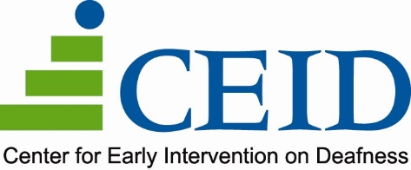 1035 Grayson Street Berkeley, CA 94710 Phone 510.848.4800 Video Phone 510.356.0004 Fax 510.848.4801 www.ceid.org

**Dispensing Audiologist**

***Part Time or Full Time Options Available***

COME MAKE A DIFFERENCE! The CEID Audiology Team is looking for collaborative and compassionate professionals to join our team. If you are passionate about working with patients of all ages, thrive in in small, engaging environments, and are eager to advance your professional expertise--We want to connect with you!

We’re currently looking for licensed, dispensing Audiologists to serve patients of all ages at our Oakland and/or Berkeley clinics. **We offer a flexible work week with options for a 3-, 4-, or 5-day week schedule.**

CEID is a non-profit organization recognized as a unique best practices site focused on maximizing communication through early education, family support and community audiology services. *This is a rare opportunity to be a part of a collaborative cross-disciplinary team to share progressive professional expertise and knowledge that provides a strong foundation for patients, students, family, and staff.*

The Dispensing Audiologist performs evaluations, screenings, and hearing aid dispensing in alignment with professional standards of practice.

**Qualified candidates will:**

* Hold a doctorate in Audiology, with appropriate licensure
* Hold a California Dispensing License (*or have the ability to obtain*)
* Be open to and experienced with serving patients of all ages
* Be passionate about quality patient care and excited to support strategies for growing our clinics in multiple ways.
* Benefit from close collaboration with a team and dedicated agency staff who are excited about providing high quality care and advanced practices.

Wage is commensurate with experience, range of $65-75/hour for Part Time, or a comparable salary for Full Time.

For candidates interested in Full-Time employment (30+ hours a week), they will be eligible for our generous benefits package prorated on the number of hours worked. Our package includes health, dental, vacation, personal, and sick time off, a voluntary 401(k) and Flexible Spending Account, discounts of agency services and through vendors, proof of employment as a qualifying nonprofit employer for the Public Service Loan Forgiveness Program, and Professional Development Opportunities.

**To apply**, please submit your resume and letter of interest to Anna Phillips, Operations Director at [anna@ceid.org](mailto:anna@ceid.org).

To learn more about our work and how you can make an impact, please visit our website at: [www.ceid.org](http://www.ceid.org).